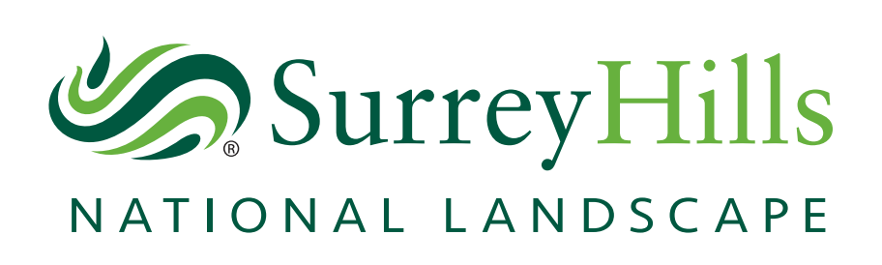
Surrey Hills Area of Outstanding Natural Beauty (AONB) Board

Notice of Meeting

Date | Venue | Contact
2 March 2022  @ 13:30 | High Ashurst Outdoor Education Centre, Mickleham, Dorking RH5 6DQ | Andre Ferreira  andre.ferreira@surreycc.gov.uk

Members of the public are welcome to attend and observe the proceedings, but because of Covid and venue restrictions, numbers will be limited. Any member of the public who wishes to attend in person, should please contact Andre Ferreira on andre.ferreira@surreycc.gov.uk by the latest 23 February 2022.
Board members and other attendees will receive a separate email with Covid requirements and logistical arrangements.

AONB Board Members
Heather Kerswell
Independent Chair

Core Members  Councillor Susan Parker  Guildford Borough Council  Councillor Claire Malcomson  Mole Valley District Council  Councillor Rosemary Absalom  Reigate and Banstead Borough Council  Councillor Geoffrey Duck  Tandridge District Council  Councillor Ruth Reed  Waverley Borough Council  Councillor Marisa Heath  Surrey County Council  Stephen Rudd  Natural England  Stephanie Fudge  The National Trust | Delivery Partners  Simon Whalley  Surrey Hills Enterprises Community Interest Company  Gordon Jackson  Surrey Hills Society and Surrey Hills Trust Fund  Advisory Members  Mike Waite  Surrey Wildlife Trust  Romy Jackson  National Farmers Union  Kristina Kenworthy  Campaign to Protect Rural England  Lisa Creaye-Griffin  Country Land and Business Association  Liz Cutter  Surrey Association of Local Councils  Observer  Ali Clarke  Surrey Hills Arts
Agenda
- Apologies for Absence

- Declarations of Interest

- Chair’s Welcome and Announcements

- Minutes of the previous meeting

- Public questions (Deadline for submissions: 23 February 2022)

- Presentation by High Ashurst Outdoor Education Centre

- AONB Boundary Extension Project

- Surrey Futures Consultation: Surrey 2050 Place Ambition

- AONB Management Plan (2020 – 2025) Monitoring Report

- Date of the next meeting

