Item 7

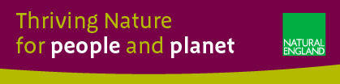

SURREY HILLS AONB BOUNDARY REVIEW
Report on Progress to the AONB Board 2nd March 2022

Purpose of the report

This is to provide the AONB Board with a report on progress, particularly around the recent evidence gathering stage, and next steps with Natural England’s project to review the boundary of the Surrey Hills AONB

To remind the Board, Section 82(1) of the Countryside and Rights of Way Act 2000 states:
“Where it appears to Natural England that an area which is in England but not in a National Park is of such outstanding natural beauty that it is desirable that the provisions of this Part relating to areas designated under this section should apply to it, Natural England may, for the purpose of conserving and enhancing the natural beauty of the area, by order designate the area for the purposes of this Part as an area of outstanding natural beauty”.
Introduction

The Written Ministerial Statement of 24th June 2021, by George Eustice Secretary of State (Defra), confirmed that Natural England is taking forward the government’s commitment to designate additional protected landscapes and is currently considering the designation of four new areas which included an extension to the Surrey Hills AONB.

Since that time, Natural England and Surrey Hills AONB officers working with the AONB Board Chairman have developed a collaborative approach with an emphasis on a comprehensive review of the boundary, undertaken as efficiently and quickly as possible whilst encouraging significant local stakeholder engagement in the process.

The June WMS was an initial response to Julian Glover’s Landscapes Review, commissioned by Michael Gove and published in September 2019. Government’s more substantive response to the ‘Glover’ Landscape Review was published on 15th January 2022.
The approach that has been developed for the Surrey Hills AONB project strikes a balance between ensuring that Natural England fulfils its statutory responsibility with the rigour that experience has shown is required in such projects, whilst developing a new way of working which is collaborative with the AONB team and seeks active and meaningful engagement with local people and stakeholders
The national importance and profile of this project was evident in the recent visit to the Surrey Hills AONB by The Rt Hon Lord Benyon, Parliamentary Under Secretary of State at the Department for Environment, Food and Rural Affairs (Defra).

Progress so Far

Management Advisory Group (MAG)

This group, meeting monthly and comprising officers from Natural England and the Surrey Hills AONB has been very active in codesigning the project, including in agreeing the ‘area of search’ and in overseeing the approach to stakeholder engagement. The MAG is chaired by Stephen Rudd, Natural England’s Senior Responsible Officer for this project.

Technical Advisory Group (TAG)

The group brings together officers from each of the relevant local authorities as key partners contributing technical expertise and relevant background evidence to support the project. The group meets on an ad hoc basis and is chaired by Ian Dunsford, Planning Policy Manager, Reigate and Banstead Borough Council.

Appointment of Consultants

Resources for Change (R4C) were appointed by Natural England in September 2021 with the initial task of undertaking a stakeholder engagement exercise in order to gather locally generated evidence. They are a consortium which collectively combines innovative approaches to stakeholder engagement with a high level of expertise in the evaluation of natural beauty.

This approach strikes a balance between assisting Natural England in fulfilling its statutory responsibility with the rigour that experience has shown is required in such projects with developing a new way of working which is collaborative with the AONB team and seeks active and meaningful engagement with local people and stakeholders.

Call for evidence 1st December 2021 – 31st January 2022 (see Annexe 1)

This comprised a website (www.surrey-hills-aonb-boundary-review.org) and online survey form developed by R4C and designed to encourage users to engage with the evidence-gathering process. The approach allowed for respondents to engage in supplying evidence at a number of levels:

- An initial, high-level response involving the minimum (mandatory) supply of a location (point), a photo of the place and a description.
- The option to engage in more depth enable stakeholders to supply further comment, photos and other supporting files as additional evidence for the
- The use of a Story Map comprising a multi-page, map-based application that combines text and images with interactive maps to provide an informative view of some of the key aspects of the boundary review process, the evaluation areas and the evidence gathered.
- At the end of the evidence gathering period we had 2117 separate evidence submissions, 1929 of which were submitted through the online portal. A further 188 submissions were received via email or post. 567 people who uploaded or sent us evidence chose to provide us with their email address, enabling ongoing engagement.
- A series of webinar briefings will be run in the second half of March to brief people on how their evidence is being used, the results of the desk research and further opportunities for engagement. People who provided contact details through the evidence gathering process will be invited and dates will be posted on the website.
Next steps in the boundary review process
Following stakeholder engagement in March, the next steps and indicative timescales for each are as follows:

- the technical assessment of natural beauty to identify possible ‘Candidate Areas’; these being areas assessed as meeting the natural beauty criterion prior to a consideration of the desirability of such areas being proposed as potential extensions to the Surrey Hills AONB - by end of May 2022
- determining the desirability of designating any such qualifying Candidate Areas, by end of June 2022
- identifying proposed revised boundaries for areas that are provisionally assessed as having outstanding natural beauty and considered ‘desirable to designate’ - by end of September 2022
- Informal and targeted consultation with the AONB Board via the MAG and with the TAG -by end of October 2022
- submission to Natural England directors for approval to undertake a statutory and public consultation -by end of November 2022
- preparation of documentation for, and subsequent undertaking of, the statutory and public consultation -by end of March 2023
- assessment of responses to the statutory and public consultation -by end of May 2023
- drafting a paper, with supporting evidence, to seek Natural England Board approval of a draft Order with regard to extending the boundary of the AONB and approval to proceed to a formal period of Notice. - by end of June 2023
- the draft legal Order would then be subject to a 28-day Notice period prior to submission to the Secretary of State (EFRA) for confirmation. The Notice period allows anyone who wishes to do so to make representations to Natural England, objecting to, supportive of, or proposing amendments to the Order, and stating the grounds on which they are made.
Following analysis of all representations made, Natural England Board will then be asked to give final approval for the submission of an Order for confirmation to the Secretary of State (Defra) varying the boundary of the Surrey hills AONB. Natural England then ‘makes’ (signs and seals) the legal Order prior to submission to the Secretary of State- by end of August 2023.

What changes as a result of designation of an area as an AONB

It is important to note that although it is Natural England’s responsibility to decide whether to designate an area as AONB, any decision made by its Board, having considered the evidence and the results of the statutory consultation, does not take effect unless and until it is confirmed by the Secretary of State (Defra). The Secretary of State has the power call a Public Inquiry if minded to do so, prior to reaching this decision.
Any areas that become a part of an extended Surrey Hills AONB, following the Secretary of State’s decision, will then have the benefit of the national status that designation brings and the statutory protection this provides. They will be fully reflected in future AONB Management Plans and benefit from the resources and skills of the AONB Management Unit. There are no changes to access rights over and above those that already exist.

Report contact: Stephen Rudd, Natural England’s Senior Responsible Officer for this project.

Stephen Rudd MCIEEM
Manager
Thames Solent Team

Tel: 07785 720536
Email: stephen.rudd@naturalengland.org.uk
website: www.gov.uk/natural-england

Annexe 1 – each dot represents a submission of evidence.

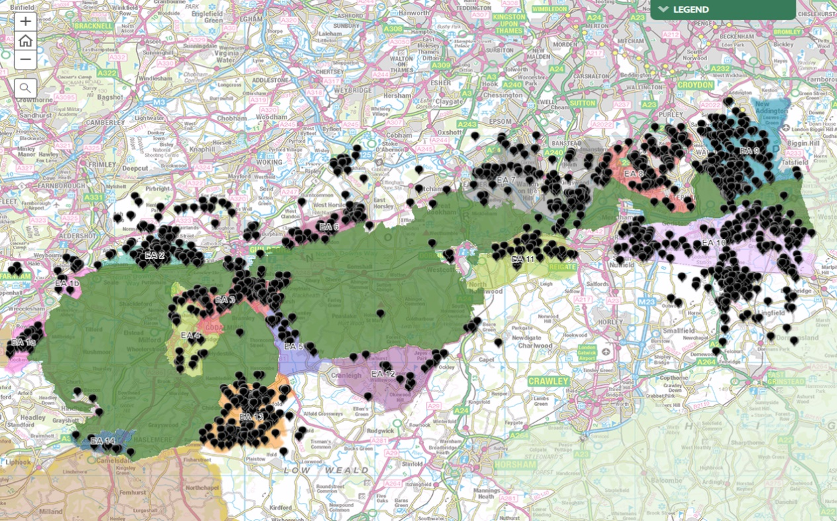

https://www.gov.uk/government/publications/landscapes-review-national-parks-and-aonbs-government-response/landscapes-review-national-parks-and-aonbs-government-response
Assuming that any proposed extensions to the Surrey Hills AONB remain unchanged following the assessment of responses to the statutory and public consultation

