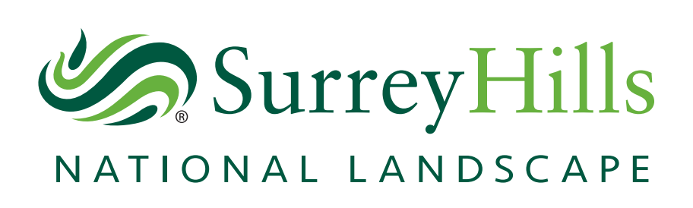
Surrey Hills Area of Outstanding Natural Beauty (AONB) Board

Notice of Meeting

Time and Date | Venue | Contact
1:30pm – 4pm  8 March 2023 | Dorking Halls  Reigate Rd, Dorking RH4 1SG | Andre Ferreira  andre.ferreira@surreycc.gov.uk

Members of the public are welcome to attend and observe the proceedings, but because of seating restrictions at the venue, numbers will be limited. Any member of the public who wishes to attend in person, should please contact Andre Ferreira on andre.ferreira@surreycc.gov.uk by the latest 3 March 2023.

AONB Board Members
Kathy Atkinson
Independent Chair

Core Members  Councillor Susan Parker  Guildford Borough Council  Councillor Claire Malcomson  Mole Valley District Council  Councillor Rosemary Absalom  Reigate and Banstead Borough Council  Councillor Catherine Sayer  Tandridge District Council  Councillor Ruth Reed  Waverley Borough Council  Councillor Marisa Heath  Surrey County Council  Stephen Rudd  Natural England  Stephanie Fudge  The National Trust | Delivery Partners  Simon Whalley  Surrey Hills Enterprises Community Interest Company  Gordon Jackson  Surrey Hills Society and Surrey Hills Trust Fund  Advisory Members  Mike Waite  Surrey Wildlife Trust  Romy Jackson  National Farmers Union  Kristina Kenworthy  Campaign to Protect Rural England  Anne Bott  Surrey Association of Local Councils  Lucy Charman  Country Land and Business Association  Observer  Alistair Burtenshaw  Surrey Hills Arts

Agenda
- Chair’s Welcome and Announcements

- Apologies for Absence

- Declarations of Interest

- Minutes of the previous meeting

- Public questions (Deadline for submissions: 1 March 2023)

- Natural England AONB Boundary Extension Update

- Surrey Hills National Landscape Board Position on Boundary Extension

- Surrey Hills National Landscape Forward Plan 2023 - 2024

- 2023 Meeting Dates

