Item 7

AONB

Surrey Hills Area of Outstanding Natural Beauty (AONB) Board

7 June 2023

SURREY HILLS TEAM RESPONSE TO EXTENSION PROJECT

Purpose of the report:

To set out the Surrey Hills National Landscape Team’s response to the consultation on the Extension Project.

Recommendations:

It is recommended that:

- Members are asked to note and advise on the Surrey Hills National Landscapes Team’s draft comments on the Natural England consultation.

Introduction:

1.1 This paper has been prepared by the Surrey Hills National Landscape Team, led by the AONB Director and Planning Adviser. led by the AONB Director and Planning Adviser in close liaison with local authority partners, has identified areas where it considers there to be evidence for further extension to those Candidate Areas identified by Natural England and its consultants. This is based on the relative weight given to natural beauty criteria, the geographical context of the Surrey Hills and recent policy drivers like the climate and biodiversity emergency.
1.2 The Natural England Guidance predates the Glover Review of Designated Landscapes which concluded that “Our country is changing fast. It is becoming more diverse. More urban. Much busier. New forms of farming, carbon emissions, the sprawl of housing, new technology and social shifts have changed the relationship between people and the countryside, and left nature and our climate in crisis. Our Designated Landscapes cannot carry on as they do now.” The Glover Review highlighted that Natural England has been working to improve the designation process, including greater involvement of local groups in gathering evidence. The Surrey Hills Team has been very supportive of this approach and the value of the evidence provided from communities and residents to identify natural beauty.
1.3 Following Glover, the Natural England Board minutes of 5th May 2021 confirmed the undertaking of the Surrey Hills AONB review and its commitment to seek a more innovative approach to reflect society’s current needs, including the opportunity to engage people with nature, most likely focused on peri-urban and urban areas. The Surrey Hills AONB being contained within the London Metropolitan Green Belt presents a great opportunity to test this innovative approach.
1.4 As much as we welcome the review, Members should be minded that Local Plan policy currently places the same protection on AONB and AGLV land. Therefore, any AGLV not included in an extended AONB and the uncertainty of the future of the Green Belt, may result in a net reduction in the area of Surrey being protected by landscape designations.

Background:

2.1 All landscapes to be designated AONB need to meet the natural beauty criteria. The Natural England Guidance on Assessing Landscapes for Designations states that “it is a very subjective characteristic of a landscape and ultimately involves a value judgement. In deciding whether an area has natural beauty, Natural England must therefore make a judgement as to whether people are likely to perceive a landscape as having sufficient natural beauty.” To make these judgements in a transparent and consistent way, the guidance sets out the following criteria:
- Landscape quality
- Scenic quality
- Relative wilderness
- Relative tranquillity
- Natural Heritage features
- Cultural Heritage
2.2 Not all factors or indicators have to be present across a landscape. The weight and importance and relative importance given to different factors and indicators will vary depending on the geographic context.
2.3 The context of the Surrey Hills as a lowland landscape, set within the London Metropolitan Green Belt, as opposed for example to remote, northern upland landscapes, means that the Surrey Hills Team considers that the relative weighting should be used when considering the extension of the Surrey Hills:

2.3.1 Great weight should be applied to the scenic beauty of views accessed by transport infrastructure and from the urban edge. Being within the busy area of London and Surrey means that the scenic quality of the Surrey Hills provides a benefit to millions of people. For example, users of the M25 and A3 benefit from outstanding views of the AONB, which provides tremendous benefits to the nation.
2.3.2 Great weight should be applied to natural heritage being bigger, better managed and better connected through the extension project. In recent years, public bodies have all declared a climate and biodiversity crisis which demands that we do need to do things differently and urgently. At the heart of national policy are the Lawton principles of nature being bigger, better managed and better connected. This is driving the priorities for the Surrey Hills around nature recovery, the Surrey Hills Making Space for Nature Strategy and Farming in Protected Landscapes (FiPL) environmental land management scheme.
2.3.3 Great weight should be applied to historic parkland and its contribution to the Surrey Hills, in particular recognising the contribution of parkland golf courses where they retain outstandingly beautiful landscapes. Human activities have had a great impact on the landscape of the Surrey Hills. Outside London, Surrey has more historic parks and gardens than any other part of the nation. The parkland is an important component of the Surrey Hills landscape, valued for its picturesque and historic interest. There is a particular relationship with formal estates and buildings on the spring line, with more formal parkland often just outside the existing AONB, but traditionally there has been a coherent relationship between the wider estate management of pasture, heaths, and woodland in the AONB. With the decline in traditional estate and farm management it is now the role of golf courses and sometimes equestrian activities to help maintain the management of these historic parkland landscapes.
2.3.4 Less weight should be applied to areas of farmland maintaining landscape quality and to acknowledge the role of conservation, golf and horse pasture in managing beautiful landscapes. The Surrey Hills AONB Management Plan describes the AONB as a landscape that has been developed and maintained by traditional farming and land management. The Plan also identifies the pressures on traditional agriculture and farming in the Surrey Hills area. These include the lack of associated infrastructure, relatively poor soils, high land values and competing pressures as well as relatively small scale and fragmented farmsteads. Although a priority is to retain our diminishing traditionally farmed landscape, economically viable activities like golf courses and horse pasture can provide for and manage beautiful landscapes.
2.3.5 Great weight should apply to relative wilderness in areas which have large uninterrupted views with minimal impact of built development. There are around 10 million people living within an hour of the Surrey Hills. With its relatively small size, this makes the Surrey Hills one of the busiest of the 44 National Landscapes. It is therefore difficult to apply the wilderness criteria in the Surrey Hills in the same way that it can be applied to very remote, extensive landscapes of the northern National Parks or the North Pennines AONB. Nevertheless, it is remarkable that there are so many vantage points across the Surrey Hills and in the proposed extension areas, with far-reaching views and without the intrusion of built development. This is further enhanced by the fact that the Surrey Hills has some of the highest cover of woodland in the country at 40% (the New Forest National Park has 36%) which helps to give the sense of remoteness and tranquillity.
2.4 Boundary considerations. In considering a coherent and defensible boundary for the Surrey Hills, the approach has been to identify major roads and railway lines. For the areas of search within the London Metropolitan Green Belt we have made use of the Green Belt as the defensible boundary in circumstances where the scenic quality of outstanding views to the adjacent countryside is considered to meet the natural beauty criteria.

Proposed Areas for Further Consideration

3.1 Based on applying the criteria set out in Section 2 of this report, the Surrey Hills National Landscape team has mapped areas where it is considered there is strong evidence for further extensions. Here is the link. Appendix 1 identifies the proposed further areas of extension in green and provides a summary of the evidence for submission to the Natural England consultation.

Next Steps

4.1 Comments from local authority partners and Members of the Board will inform the Surrey Hills National Landscapes Team’s response, although it is acknowledged that Board Members and partner organisations will submit their own response to the consultation. Natural England will determine whether the evidence for the proposed areas meet the criteria and, if so, these areas will be subject to a technical appraisal and further public consultation as part of the process.

-------------------------------------------------------------------------------------------------------

Report contact: Rob Fairbanks, Surrey Hills AONB Director

Contact details: 07772 365036
rob.fairbanks@surreyhills.org

APPENDIX 1. AREAS PROPOSED FOR FURTHER EXTENSION
Key.
Pink | Existing AONB
Blue | Candidate Area
Green | Proposed Extension Area

- Eashing to Godalming Lammas Land.
There is strong evidence of outstanding scenic beauty that extends across the A3, linking to the existing AONB. This includes the historic village of Eashing with its Grade 1 listed medieval bridge. High natural heritage value of the Wey corridor linking with proposed Candidate Area of the Lammas Lands in Godalming. Less weight is put on the intrusive impact of tranquillity of the A3.
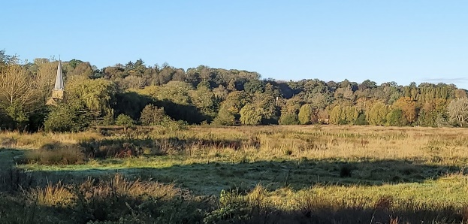
The Lammas Lands

- Clandon, Hatchlands and West Horsley Place.
This area links the scenic qualities of the historic parkland landscapes of Clandon, Hatchlands and West Horsley Place. The downs of the Surrey Hills are integrally connected to the adjacent parkland landscapes, with the historic houses built on the spring line at the foot of the downs. The railway lines offer a coherent and defensible boundary of an extended AONB.
The outstanding views onto the downs and from the downs sweep across the A246. Although Clandon Park is perhaps lesser connected, it nonetheless has a high level of scenic beauty and historic heritage associated with the Surrey Hills. The Clandon Regis golf course retains much of the historic parkland and the Clandon Woods Nature Reserve has a high level of natural heritage worthy of AONB inclusion. The historic conservation villages of East Clandon and West Horsley have a high cultural heritage value and attractive buildings within the Surrey Hills AONB setting.

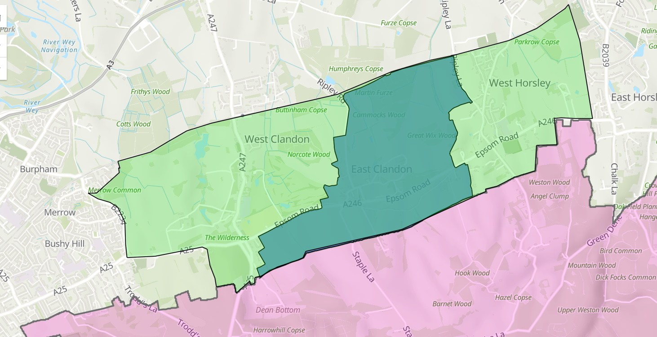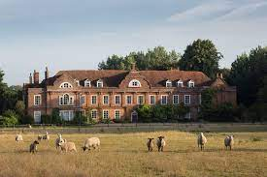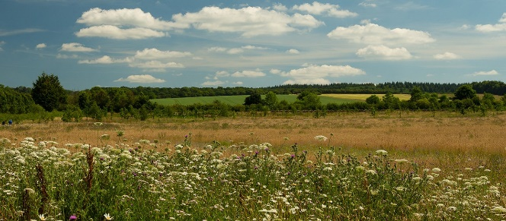
Clandon Woods Nature Reserve West Horsley Place

- Cherkley Court
Cherkley Court is an historic parkland landscape with strong cultural associations linked to Lord Beaverbrook and Winston Churchill. The setting of the estate buildings offers outstanding views to and from the existing AONB described as being `nestled in the Surrey Hills’ and the new golf course retains much openness, working with the landform and with outstanding views south to Mole Gap and north towards London.
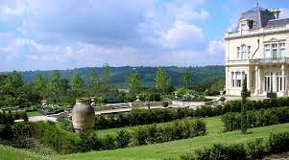

- Land south of Great Bookham
A small area of approximately 100 of horse pasture associated with equestrian centre below Great Bookham. This contributes greatly to the far-reaching views from it are best seen from the top of Crabtree Lane, as pictured.
- Land west of Dorking
Clay Copse, Milton Court Farm and Milton Heath. Area of sloping farmland at the foot of the chalk ridge, includes some intact hedgerows and is visually contiguous with the valley landscape to the west. This land was identified for inclusion within the AONB by the earlier Hankinson Duckett report.

- Okewood Hill and Wallis Wood
The is an extensive area of predominantly ancient woodland in the weald landscape below Leith Hill. it has a remote and tranquil character, despite the extensive settlement patterns, secluded woodland gyhls, parkland with vantage points that offer uninterrupted views across the Surrey Hills.,
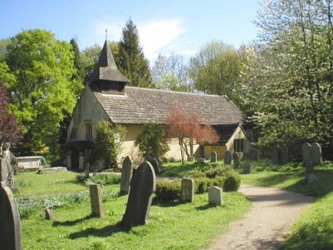

- Ockley
Along with Mole Valley DC, the Surrey Hills team is proposing two small extensions where the landscape character and scenic quality is consistent with the adjacent AONB and proposed extension area, creating a coherent defensible boundary along the railway line.
- Shagbrook, Buckland
This is a small area within a proposed extension area that Mole Valley DC officers and the Surrey Hills Team consider should be included too as it is integral to the wider character and its intrinsic scenic and natural heritage qualities.
- Langley Vale and Banstead Heath
The views south from the Epsom Downs Racecourse have far-reaching, outstanding views. The new Woodland Trust Commemorative Woodland at Langley Vale is a nationally important site which the Woodland Trust describes as having “pockets of ancient woodland, diverse and fascinating wildlife and flora, and stunning views over the rolling hills”.
The intimate land around Walton Heath and village, and the outstanding Walton Heath Golf Course create a coherent link between Langley Vale and the Banstead Downs, which has outstanding, far-reaching views. Less weight is given to the intrusive impact of the A217 at Kingswood and the M25.
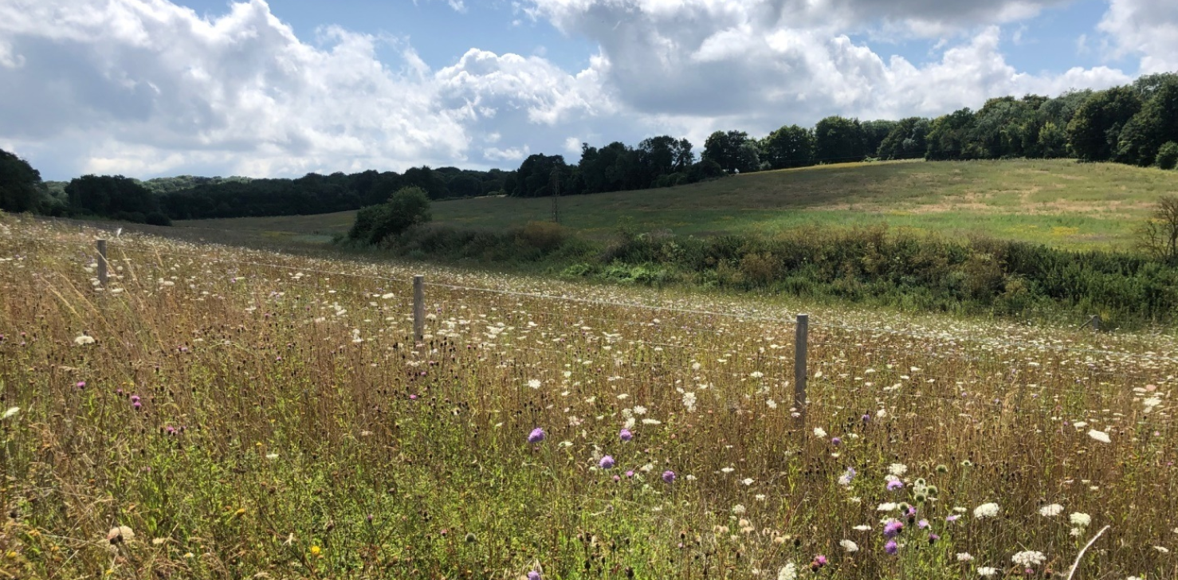
Langley Vale woodland
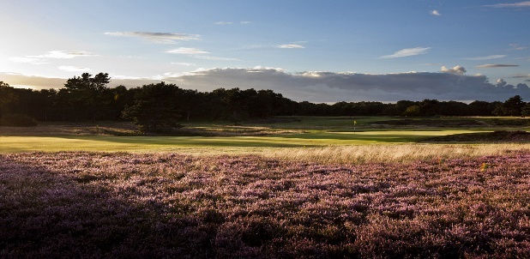
Banstead Downs Walton Heath Golf Club
- Chaldon, Dollyper Hill, Coulsdon and Kenley Commons
This proposes evidence to extend the AONB west from the Happy Valley Candidate Area across the attractive part of Chaldon village and to include the scenic golf course with its dramatic landform and mature woodland. The contiguous areas to the north all form part of the South London Downs National Nature Reserve. There are outstanding open views across the proposed extension area and the woodland helps to mitigate the views out towards the adjacent urban areas. Kenley Airfield itself is considered to be a beautiful open space with species rich grassland and is home to the Surrey Hills Gliders, giving it a sense of place and military heritage. This area is considered to meet the natural beauty criteria and offers a fantastic opportunity for linking to the AONB and managing nature so that the area is bigger, better connected and better protected.

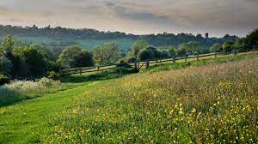
Dollymore Nature Reserve
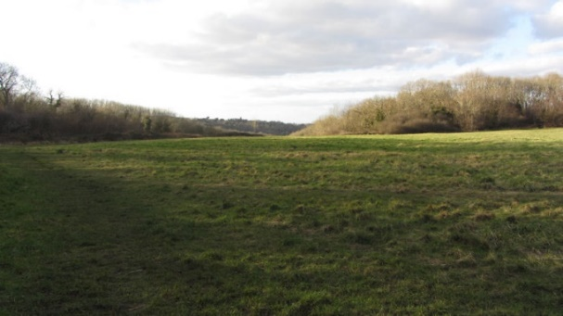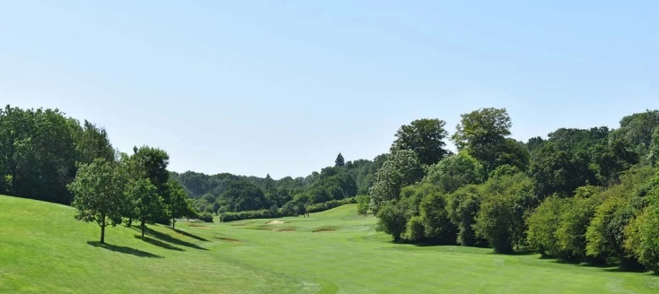
Kenley Common Surrey National golf course

- Warlingham, Fairleigh, Chelsham and Tatsfield
The Surrey Hills National Landscapes Team considers that Natural England should further consider evidence to include the Beddlestead Valley and its surrounds, between the B269 and Tatfield/Biggin Hill, within the extended Surrey Hills AONB. This area has a dispersed rural character which is remarkable being so close to London. The Beddlestead Valley is a classic chalk dip slope landscape, with dry valleys, wooded coppice and single track lanes.

In terms of built heritage, the area includes the hamlet of Farleigh, with the St Mary the Virgin Medieval Church (1080), the hamlet of Fickleshole, with The White Bear, and the village of Chelsham have an intrinsic value from their setting within the landscape.

The golf courses are also intrinsically curved into the landscape and retain a remarkable sense of remoteness, given their proximity to London, and retain an historic parkland character. The Selsdon golf course, adjacent to the area being put forward, is transforming into one of London’s largest `re-wildling’ projects. Selsdon Wood and Hutchinson’s Bank Nature Reserve are both on the urban edge but have outstanding natural heritage, with far-reaching views to the proposed extension area.
H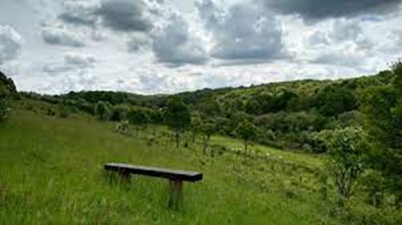 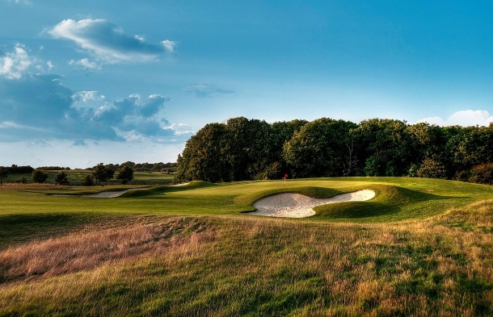
Hutchinsons Bank and Farleigh golf course
- Godstone East
An area of ancient woodland, historic moat, fisheries and parkland golf course with outstanding scenic beauty situated between existing AONB and Candidate Areas to the east and south.
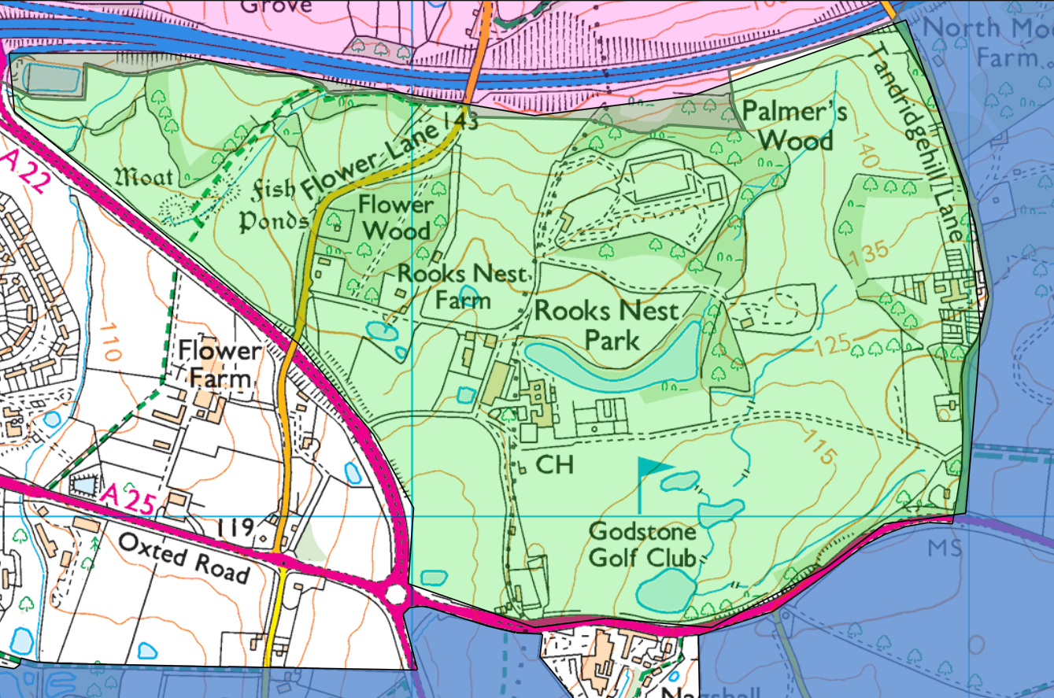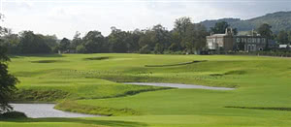
Goldstone parkland golf course
- Land around South Godstone
The is recognised in the report as a zone of transition. We support Tandridge DC technical assessment that the AONB should be extended to meet the railway line and include the historic farmsteads and fields around South Godstone.
