

LOVE DOGS, LOVE NATURE
PROJECT REPORT
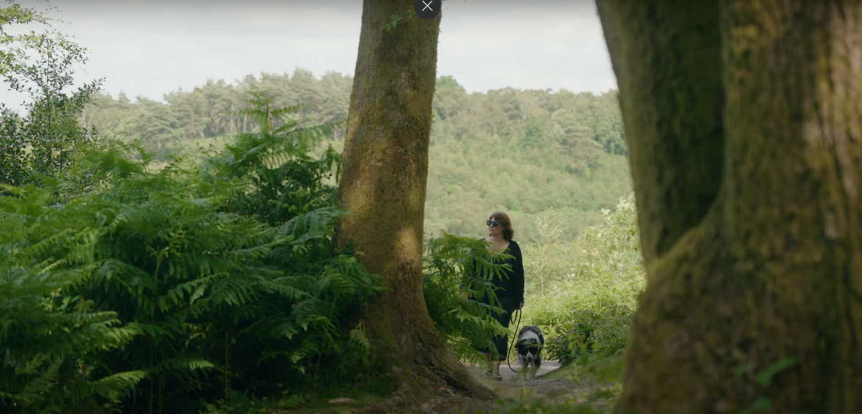

Thomas Roberts
Haeyoung Eun
Institute for Sustainability, University of Surrey


TABLE OF CONTENTS
- INTRODUCTION  Background  - METHODOLOGY  - BENEFITS OF DOG WALKING  - DIFFERENT TYPES OF DOG WALKERS  - CHALLENGES ASSOCIATED WITH DOG WALKING  - Dog Faeces  Use of dog waste bins  - Wildlife and Animal Disturbance  - Conflicts with Other Countryside Users  - SOLUTIONS  - Dog Zones and Dedicated Walking Routes  - Appropriate Signage  - Dog Walking Facilities  - Engagement and Outreach  - CONCLUSIONS AND RECOMMENDATIONS  - APPENDIX  - REFERENCES | 3  3  5  7  8  10  10  11  12  12  14  14  15  17  18  20  22  23

Acknowledgments and funding statement
This work was funded by the Surrey Hills National Landscape and is published under the auspices of the Institute for Sustainability at the University of Surrey, the Surrey Hills National Landscape, and the Surrey Nature Partnership. The authors and the Surrey Hills National Landscape gratefully acknowledge the organisations and individuals who generously contributed their time and expertise to this project.
To cite this document: Roberts, T., & Eun, H. (2025). Love dogs, love nature: Project report. Institute for Sustainability. For further details about the report please contact Dr Thomas Roberts: t.m.roberts@surrey.ac.uk

1. INTRODUCTION
Background
This report outlines the findings from research undertaken into dog walking practices within the Surrey Hills National Landscape. The research was carried out by researchers from the Sustainability Innovation Hub at the University of Surrey on behalf of the Surrey Hills National Landscape. The purpose of the report is to provide an overview of the literature regarding sustainable dog walking practices and present the findings from a series observations of dog walkers carried out at four key sites across the Surrey Hills National Landscape. The report aims to highlight the benefits associated with dog walking as well as the challenges it presents for nature recovery and conflict with other countryside users (particularly livestock farmers). The report concludes with a series of recommendations on the development of sustainable dog walking practices: these focus on physical infrastructure changes, appropriate signage, and public information/education campaigns.
The research has been undertaken in the context of growing concerns regarding the environmental impact of dog ownership (Bateman and Gilson, 2025) and a significant growth in the domestic dog population. Since 2011, the number of pet dogs in the UK has nearly doubled from 7.6 million to 13.5 million (UK Pet Food, 2024) and research undertaken by Natural England shows that Dog walking is the most common reason for visiting the country side in England (Natural England, 2019). This has led to a dramatic increase in dog walking activity, placing significant pressure on the countryside and an increase in conflicts between dog walkers and other countryside users (Bennett et al., 2018; Ly, 2022; Maguire et al., 2019). Specific data on the number of dogs utilising the Surrey Hills National Landscape is not available – however, 43% of the respondents to the survey commissioned to inform Surrey County Council’s Rights of Way Improvement Plan classified themselves as dog walkers (Surrey County Council, 2024). Furthermore, during the observations carried out for this study, over 80% of walkers observed were accompanied by at least one dog. Consequently, there is an urgent need to review the way in which dogs are managed within the Surrey Hills National Landscape.
The next section outlines the methodologies utilised to collect both the primary data and secondary data presented in this report. Section 3 provides an overview of some of the latest research into the benefits of dog walking, highlighting its importance for both mental and physical health. Section 4 outlines the different types of dog walking activity observed in the Surrey Hills and why these distinctions are important. Section 5 draws on the literature, findings from the observations and deliberative workshop to provide an overview of the current challenges dog walking is presenting for the Surrey Hills National Landscape. Section 6 focuses on a range of measures which could be utilised to mitigate against some of the most serious negative impacts of dog walking and explores how they could be implemented within the Surrey Hills. The final section (section 7) brings together the different elements of this research to outline a plan of action to maximise the enjoyment and benefits of dog walking in the Surrey Hills, whilst minimising the environmental impact and conflict with other users and encouraging nature recovery.

2. METHODOLOGY
The primary purpose of this report is to highlight best practices associated with sustainable dog walking and apply it to the current challenges faced by the Surrey Hills National Landscape. To achieve this a multi-method approach was required consisting of a systematic review of existing literature, non-participant observation of dog walkers at four sites across the Surrey hills National Landscape and a deliberative workshop with land managers.
The search strategy to identify relevant research for the systematic review of the literature was developed in partnership with the team from Surrey Hills National Landscape to establish a broad set of search terms which incorporate the health and wellbeing benefits, environmental challenges associated with dog walking as well as examples of approaches which have been effective in reducing the impact. This resulted in the following terms being used in the search: Dog ownership; dog walking and physical health; dog walking and mental health; impacts of dogs on biodiversity; Dogs and the transmission of Neosporin; conflict between dog walkers and other countryside users; reducing the environmental impact of dog walking; signage and dog walking; sustainability and dog walking.
The searches based on these terms were carried out using Google Scholar and Google, in order to capture both academic studies and research conducted by other organisations such as Government bodies, NGOs and think tanks. The search took place in April 2025 and for each search the titles in the first ten pages of search results were scanned for relevance (non-research-based results from the Google search were excluded). The remaining documents were screened for eligibility (relevance to the present research and the UK context). A few additional papers of interest were uncovered during the writing process through examining reference lists.
The literature was followed by a series of observations at four popular dog walking sites across the Surrey Hills National Landscape:
- Puttenham Common - Heathland
- The Chantries and St Martha’s - Woodland/Heathland
- Norbury Park - Farmland with public access rights
- Denbies Wine Estate - Vineyard with shops and café
Observation was the ideal approach to use as it allows the researcher to establish the reality on the ground and gain an insight into real world behaviours. This is essential when researching an issue such as dog walking which has become contentious with different interest groups expressing strong and often opposing opinions on the nature and impact of the activities being undertaken. Furthermore, as revealed by the research, a lot of dog walking activity is highly habitual, which can make it very difficult for participants to accurately self-report on the details of their dog walking practices (Lashley, 2017).
The purpose of the observation was to get a sense of how dog walkers were using the sites, the nature of their behaviour and the extent to which they were complying with the guidance outlined on signs located at the sites. In particular we were keen to observe whether dogs were on or off the lead, if they were off the lead how much control owners had over them and whether they were sticking to footpaths and whether walkers were clearing up faeces and using the dog waste bins provided. In addition, we were also interested in getting a sense of the different types of dog walking activities which were occurring across the sites. A summary of the observations recorded at the four sites can be seen in Appendix 1.
The final stage of the research was to engage with a wide range of stakeholders who are currently dealing with the challenges associated with dog walking across the Surrey Hills National Landscape. A deliberative workshop was chosen as this approach allows the researchers to present the findings from the research so far, pose specific questions and encourage discussion between the participants (Fishkin and Luskin, 2005). Invites were sent to landowners, farmers, business owners, and land managers - a total of 15 people responded and attended the half-day workshop hosted at the Denbies Wine Estate.

3. BENEFITS OF DOG WALKING
Dog walking is about far more than just exercising the dog, there are many different benefits to dog walking for the owners as well (Westgarth et al., 2021). First, dog walking provides owners with the opportunity to engage in regular exercise, which improves overall physical health (Chen et al., 2022). It has been proven that dog owners are more likely to engage in physical activities than people who do not own dogs, and dog ownership is associated with a reduced chance of cardiovascular risk and all-cause mortality (Kramer et al., 2019; Levine et al., 2013).
There is also a growing body of evidence pointing towards the social and mental health benefits of dog walking. It can be a highly social activity, creating opportunities for owners to interact with other people, by having conversations with other dog owners or those interested in dogs. It can also be a catalyst for groups of people to get together to walk their dogs and create new friendship groups (Edwards and Knight, 2006). Research has shown that owners experience a range of positive emotions while walking with their dogs (Westgarth et al., 2017). The activity provides an opportunity for owners to relax and alleviate stress. Additionally, walking with a canine companion gives a sense of safety and security (Edwards and Knight, 2006), which can be more comforting than walking alone.
Dog walking is not just good for the owners and the dogs - it can contribute to land management and support the rural economy. Regular visitors to specific dog walking areas can identify and report issues like vandalism, pollution, wildfires, and antisocial behaviours. Additionally, dog walkers visiting rural sites are important for a wide rage of local businesses such as cafes and gift shops (Scottish Natural Heritage, 2015).

4. DIFFERENT TYPES OF DOG WALKERS
In order to be able to develop effective management plans to address the current challenges associated with dog walking, it is important to first understand the diverse nature of the activities which are occurring. This will enable us to identify interventions which are appropriate to the activity taking place.
Westgarth et al. (2021) makes the distinction between two key types of dog walking activity, functional and recreational. Functional walks generally occurred close to home and are primarily aimed at meeting the dogs need for physical exercise, urinating and defecating. These are normally carried out by individuals on their own and owners are often motivated by the desire to avoid feelings of guilt if the dog is not walked. Recreational walks, tended to be undertaken in more preferable locations and focused on the owners needs to de-stress and relax as well as the dog’s physical wellbeing. Recreational walks are often seen as an opportunity to bond with family and friends and undertaken as part of larger groups.
During the observations in the Surrey Hills National Landscape, we observed evidence of both functional and recreational dog walking across all four sites. Although, most walkers using the Norbury park site appeared to be functional walkers and recreational walking was more popular at Denbies (the results from St Martha’s and Putnam Common were more mixed). Functional dog walkers were easy to identify, they were normally on their own and it was clear that both the owners and the dogs were following well-practiced habitual routines on relatively short walks (between 15 and 30 mins). Dogs were clipped on and off the lead at set points in the walk, defecation and urination occurred at specific points and well-practiced routes were followed. Conversely, recreational walkers tended to embark on much longer walks often in small groups with one or more dog. Both owners and dogs were less familiar with the routes and surroundings resulting in far less habitual behaviour. In some cases, this led to a much higher level of awareness of the natural environment and the behaviour of the dog, but in other cases, the presence of other people meant the dog owners were more engaged with their fellow walkers and therefore paid little attention to the dog and what it was doing.
In addition to the functional and recreational categories of dog walkers, the researchers identified a third category, professional dog walkers. These were professionals being paid to walk multiple dogs and observed across all four sites walking between three and eight dogs. Both the dogs and the walkers were exhibiting typical functional dog walking behaviour following clearly defined well-known routes. All the dogs observed being walked by professional dog walkers remained on leads at all times.

5. CHALLENGES ASSOCIATED WITH DOG WALKING
Despite the numerous social, health and economic benefits associated with dog walking, when left unmanaged it can present a range of challenging environmental problems and create conflict between countryside stakeholders.
5.1. Dog Faeces
Findings from surveys suggest that most dog walkers claim to always clear up their dog faeces. However, the reality on the ground is often different with faeces often left on the ground or bagged up and then hung on trees or left lying around (Bennett et al., 2018). Failure to clear up dog faeces can lead to an increase in the amount of nutrients in the soil with adverse impacts on plants and biodiversity, causing habitat destruction and undermining nature recovery initiatives (De Frenne et al., 2022). Dog faeces also spread disease to farm animals and people. Of particular concern to livestock farmers is the spread of Neospora caninum which causes reproductive problems and abortion in cows which are infected by ingesting food or drinking water contaminated by Neospora from the feces of dogs (Fayisa, 2024). Furthermore, dog feces can also cause Toxocariasis, which is a dangerous infection that can damage the lungs, liver, central nervous system, and eyes in humans (Woodhall and Fiore, 2014). Children are at most high risk as they are more likely to be in contact with sand or soil that contains dog mess (Despommier, 2003).
The risks associated with dog faeces are generally well known and feature prominently on signage across the Surrey Hills National Landscape. Furthermore, significant efforts have been made to provide dog waste bins at all the sites where observations were carried out. Nevertheless, the researchers observed a significant quantity of dog faeces and discarded dog waste bags (both used and unused) and numerous dog walkers failing to pick up their dogs’ faeces.
There were a number of clear patterns in the circumstances surrounding the failure to pick up dog faeces. In general, if the dog was on the lead when defecating the walker was far more likely to pick up the faeces. However, there were a number of exceptions to this:
- Professional dog walkers in control of multiple dogs – On three occasions (two at Norbury Park and one at St Martha’s), we observed dogs defecating while on the lead being walked in groups of between four and eight dogs. On each of these occasions the walker tried to clear up the faeces, but was unable to while keeping the other dogs under control.
- Elderly dog walkers – On two occasions (one at St Martha’s; one at Puttenham Common) we observed elderly dog walkers attempting but failing to clear up after their dog. Again, it appeared that they were struggling to keep control of the dog on the lead whilst bending down to remove the faeces.
The vast majority of incidents of dog walkers failing to pick up faeces occurred when the dog was running free off the lead and the walker did not notice (or possibly chose to ignore) the dog defecating. Again, there were a number of clearly observable pattens leading up to this behaviour:
- Lone ‘functional’ dog walkers distracted by devices – This was by far the most common reason for dog walkers’ failing to pick up their dogs’ faeces. Numerous occurrences were observed across all four sites but it was particularly notable at Norbury park. Soon after arrival at the car par, the dogs were generally let of the lead and allowed to run free, it was clear that both the dogs and the owners were following well-practiced routines with owners wearing headphones and largely ignoring where the dog was going and what it was doing.
- Groups of ‘recreational’ dog walkers engaging with each other and ignoring the dogs – Primarily observed during weekend observations at St Martha’s, Puttenham Common, and Denbies. Generally, dogs were kept on the lead for the first part of the walk until they had settled into a routine, dogs were then released and largely ignored by the walkers who were engaged in conversation with each other. This often resulted in failure to notice when dogs were defecating.
Use of dog waste bins
Dog waste bins were available and appeared to be well used at all four observation sites. However, the current positioning of these bins — mainly in or near the car parks — may not align well with actual dog walking behaviour. Observations revealed that many dogs, especially those on routine, functional walks, defecated within the first five minutes of the walk. As a result, walkers faced a dilemma: either carry the waste for the duration of the walk or return to the car park to dispose of it.
This likely contributes to the high incidence of dog waste left on the ground or abandoned in bags near the car park area. This pattern suggests that the inconvenience of the bin location might be discouraging some users from properly disposing of waste.
5.2. Wildlife and Animal Disturbance
There is a well-established body of evidence demonstrating the negative impacts that dogs can have on wildlife, particularly on ground-nesting birds during the nesting season (April to August), through disturbing nesting sites, crushing eggs, and preying on chicks and adult birds (Lafferty et al., 2006; Maguire et al., 2019; Showler et al., 2010; Weston et al., 2012). Disturbance occurs when dogs stray from established paths and rummage through undergrowth — a behaviour observed multiple times across all sites, when dogs were off-lead. This impact was further exacerbated when dog walkers were not paying attention to where their dogs were or what they were doing. Similar to the issue of uncollected dog faeces, walkers who were wearing headphones, distracted by mobile devices, or engaged in conversation with others appeared significantly less aware of their dogs’ whereabouts and behaviour.
There were, however, a number of noteworthy exceptions. Walkers who were fully engaged with their dog interacting with it and had excellent recall were able to keep their dogs under control even off the lead.
In addition to the risks associated with Neospora transmission from dog faeces, dogs themselves can pose a significant threat to livestock. Even well-trained dogs may exhibit predatory behaviour around farm animals, leading to considerable stress, injury, or in some cases, fatal outcomes (Taylor et al., 2005). While no incidents of livestock worrying were directly observed during the site visits, several farmers participating in the deliberative workshops reported a noticeable increase in such incidents. They expressed concern about the growing impact these encounters are having on the health and welfare of their animals.
5.3. Conflicts with Other Countryside Users
Uncontrolled dogs can also negatively impact the experience of other countryside users. Dogs off-lead may pose a perceived or actual risk of attack, and many people report feeling fearful or uncomfortable when approached by an unfamiliar dog (Taylor et al., 2005). This can significantly reduce the sense of safety and enjoyment for walkers, families, and other recreational visitors.
This issue was directly observed on several occasions during the fieldwork, most notably at St Martha’s and the Denbies Estate. At these sites, dogs were seen boisterously approaching other walkers, and in one instance, a horse rider. In all but one case, the dog owners apologised for their dogs’ behaviour but were quick to emphasise that their pets were “just being friendly.” Additionally, at the Denbies Estate, one particularly concerning incident involved an aggressive dog and owner who were seen harassing and intimidating both other walkers and their dogs.
Another general observation across all sites was that the vast majority of visitors were accompanied by at least one dog. This raises important questions about the apparent underrepresentation of non-dog walkers and why they may not be using these sites. It suggests a potential barrier to wider public access or enjoyment, possibly linked to concerns about uncontrolled dogs, perceived user conflicts, or a general sense that these spaces are primarily for dog walking.

- SOLUTIONS
Dog walking offers numerous benefits for human health and wellbeing. It encourages regular outdoor activity, provides opportunities to connect with nature, and can foster a deeper appreciation for the natural environment. Many individuals choose to become dog owners specifically to spend more time outside, and some evidence suggests that dog ownership may be linked to increased environmental awareness (Colléony et al., 2019). In short, many dog owners have a strong affinity for both their pets and the natural world, and their presence in these landscapes reflects a genuine desire to engage with and care for nature. This represents a strong starting point for land managers and dog walkers to co-design appropriate mechanisms to mitigate against the most harmful elements of dog walking and allow dogs and nature to co-exist.
6.1. Dog Zones and Dedicated Walking Routes
One approach that can be taken to provide dog walkers with access to the countryside, whilst minimizing conflicts with other users and protecting biodiversity is to create designated areas for dogs. Setting aside a part of land that is less sensitive to create a special recreational area for dogs has been proven to be one of the most effective ways to encourage voluntary compliance from dog walkers (Dayer et al., 2022). This can take a number of different formats, such as a dedicated off-lead field with sensory and physical activities to engage both dogs and their owners. Alternatively, specific paths and walking routes could be created at popular sites to keep dogs, livestock and sensitive habitats separate. These could either be separated using permanent fences or temporary barriers such as dead hedging to protect sensitive habitats at particular times of year. It has been noted that where possible natural materials should be used for fencing, creating an interesting and stimulating environment for dogs to explore. Furthermore, letting vegetation grow along fences and pathways helps block the view between dogs, wildlife, and livestock, which lowers the risk of visual triggers or chasing behaviour (Forestry Commission, 2025).
The introduction of such initiatives was central to much of the discussions during the deliberative workshops. Land managers were broadly supportive and generally very willing to give up part of their land to protect the rest of it. However, several challenges associated with such schemes which need to be overcome were noted:
- Difficulty getting planning permission – It was noted numerous times that various landowners across the Surrey Hills had tried to provide dedicated dog walking fields and facilities. However, numerous examples of failed planning permission were highlighted. There was also some concern about the impact on access rights even when temporary barriers such as dead hedging were utilised.
- Duty of care and insurance - Several landowners highlighted the insurance challenges associated with such initiative, particular in relation to making sure users were aware of the limits of insurance cover and ensuring compliance with rules and regulations
- Funding – Questions were raised about who should pay for the establishment of such facilities, how they should be funded, if they should be free to use or require payment. If payments were required there were questions about appropriate fees and how payment processes could be managed.
- Increase in dog numbers – There were also some concerns that providing additional facilities for dogs and dog owners could lead to an increase in dog walking activities further exasperating the existing problem
In short, dedicated dog zones and walking routes have the potential to relive pressure on the most sensitive sites and provide a rewarding experience for dog walkers. However, in order to be successful there are a range of administrative legal and practical issues which need to be resolved.
6.2. Appropriate Signage
Signage that promotes safe and sustainable dog walking is central to efforts aimed at managing dog walking activities and encouraging compliance among dog owners (Bennett et al., 2018; Dayer et al., 2022). A substantial body of research has investigated the most effective types of signage for influencing walker behaviour, and numerous regulatory bodies, including Natural England, have issued guidance based on this evidence.
For signage to be effective, careful consideration must be given to both its content and its placement. Observations across all four sites revealed a variety of sign types; however, very few dog walkers appeared to actively engage with them. One notable exception occurred at Puttenham Common, where a sign was being repaired. Regular walkers showed interest, possibly to check for new information. This incident underscored the importance of keeping signage current and engaging. In particular, seasonal signage — such as warnings about ground-nesting birds or wildfire risks — should be removed at the end of the relevant season and reinstalled the following year. Regular updates help maintain visibility and relevance, especially for functional habitual walkers who may otherwise become desensitised to static signs along familiar routes.
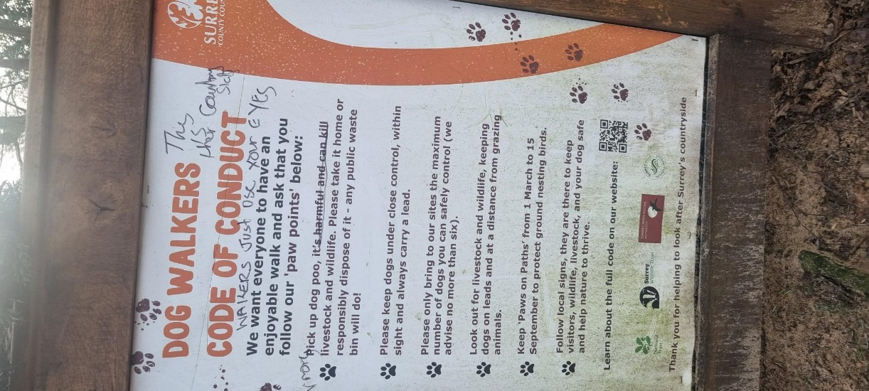
A number of signs observed during the study had been vandalised. In some cases, signs were physically damaged, while others had been defaced with graffiti. Notably, comments or directives concerning issues such as dog fouling and the requirement to keep dogs on leads were often crossed out or altered (see Figure 1). This behaviour aligns with findings from previous research, which suggest that visitors are more likely to respond positively to communications that highlight permissible actions rather than restrictions. Positive, solution-focused messaging — emphasising what visitors can do rather than what they cannot do — has been shown to be more effective in encouraging compliance (Forestry Commission, 2025; Scottish Natural Heritage, 2015).
Much of the current signage observed focuses on highlighting walker responsibility and the consequences of non-compliance. For example, at Norbury Park, several old and weathered handmade signs were noted, featuring graphic images of stillborn calves alongside warnings about the transmission of Neospora via dog faeces. While the intention is to inform, such messaging risks setting an adversarial tone, potentially exacerbating tensions between user groups. Rather than Figure 1. Graffitied sign at St Martha’s
fostering a sense of shared stewardship, these signs may reinforce division. Research suggests that communications which appeal to common values — such as a mutual appreciation for the countryside — are more likely to foster cooperation and responsible behaviour among all visitors.
Previous research has emphasised the importance of clear and consistent messaging that guides behaviour by focusing on what visitors can do, rather than simply listing prohibitions (Edwards and Knight, 2006). Signage text should be short and concise, using large, legible fonts to maximise readability (Dayer et al., 2022; Natural England, 2024). While symbols and images can enhance understanding, it is essential to avoid overwhelming users with excessive content. Concentrating on one or two key messages is more effective than presenting long lists of rules and regulations. Reinforcing these messages along popular walking routes can further enhance their impact. A strong example of this approach was observed at Puttenham Common, where informative yet accessible signage about the need to keep the dogs on leads during the ground-nesting bird season was placed in the car park and supported by simple reminders at regular intervals throughout the site.
There is also considerable evidence suggesting that educational signage is often more effective than purely regulatory messaging. Visitors to these sites typically have an existing appreciation for nature and demonstrate both a willingness and an interest in learning how to protect it. Educational signs that explain ecological issues or the rationale behind certain behavioural expectations can foster a sense of shared responsibility. Where regulatory signs are necessary, they are most effective when co-located with educational messages that provide context and explain the reasons behind the rules (Dayer et al., 2022). This approach helps build understanding and cooperation, rather than resistance or resentment.
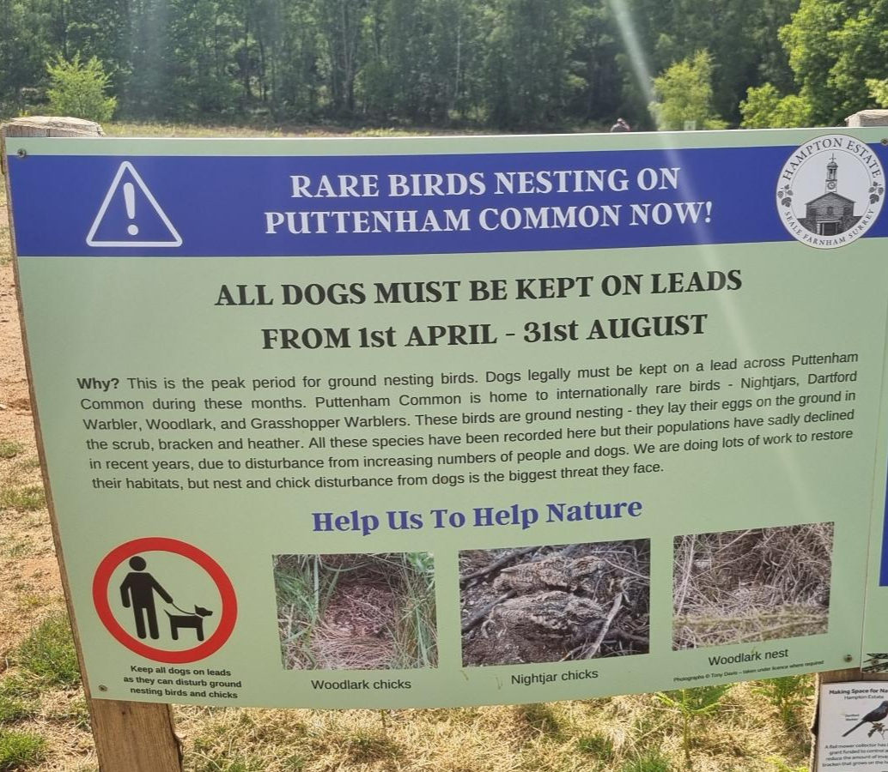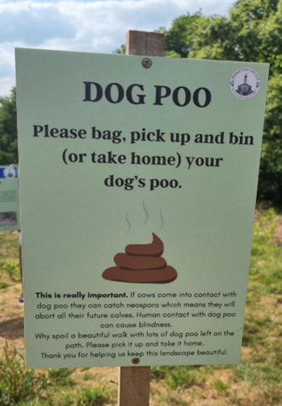
Figure 2. Information signs at Puttenham Common
6.3. Dog Walking Facilities
The presence of appropriate and well-maintained infrastructure can significantly support and promote sustainable dog walking, especially when complemented by clear and informative signage. Perhaps the most critical infrastructure element is the provision of conveniently placed dog waste bins. As noted earlier, the majority of bins observed during the research were located in or near car parks at the beginning or end of walking routes. This placement can be problematic, particularly if a dog defecates early in the walk — forcing the owner to either backtrack or carry the waste for the remainder of the route. As such, placing bins further along walking paths could encourage more consistent disposal behaviour.
This issue was raised during the deliberative workshop, where land managers acknowledged the problem but also highlighted the logistical challenges of servicing bins located away from main access points. Additionally, the importance of regular emptying was emphasised in both observational work and workshop discussions. Overflowing bins often lead walkers to leave bagged waste nearby, undermining the intent of the infrastructure.
Beyond waste disposal, other dog-friendly amenities — such as cafes that welcome dogs or facilities for refilling water bowls — can also help attract dog walkers to particular sites. This can provide an opportunity to ease pressure on more sensitive or less resilient areas. Such amenities may also help foster a sense of belonging and stewardship among dog walkers, encouraging them to take greater responsibility for protecting and caring for their favourite walking spots (Edwards and Knight, 2006).
6.4. Engagement and Outreach
Designated walking routes, dedicated dog zones, high-quality facilities, and well-designed signage can all contribute to encouraging more sustainable dog walking practices. However, these measures are most effective when paired with a continuous program of public engagement and outreach. As noted, dog walkers may not always pay attention to signage; some may misunderstand the guidance, while others might choose to ignore it, believing their own dog is well-behaved and exempt from the rules. Many of these challenges can be effectively addressed through direct interaction, where staff and volunteers engage with dog walkers to explain the reasons behind certain rules and promote responsible behaviour (Dayer et al., 2022).
Engagement and outreach can take many forms and be carried out by a wide range of individuals, including land managers, volunteers, and members of the local community. Over time, such efforts can help foster a network of regular dog walkers who model responsible behaviour and may even serve as volunteer wardens, engaging with others and promoting best practices. Incentives and targeted campaigns can act as catalysts for this kind of engagement. For example, the Hampton Estate team has distributed free dog leads and bandanas during the ground-nesting bird season to encourage walkers to keep their dogs on a lead. These items not only serve a practical purpose but also provide a natural starting point for conversation, helping to raise awareness about sensitive wildlife habitats. The bright purple leads, emblazoned with the message ‘Love Dogs, Love Nature’, are designed to be highly visible, with the hope that their widespread use will build a sense of shared identity among walkers and encourage more sustainable behaviours.
As noted above, dog walkers who are distracted — whether by mobile devices or by walking in groups and engaging in conversation — may not be fully attentive to their dogs. This lack of engagement can lead to a range of issues, from failing to pick up dog waste to conflicts with livestock and wildlife. One effective way to address these challenges is by offering free training sessions and advice to dog walkers, helping them understand how to make walks enjoyable and beneficial for both themselves and their dogs. As with other outreach initiatives, the offer of something free can be a valuable way to initiate engagement, opening the door to conversations and increasing awareness of responsible and sustainable dog walking practices.
Whilst outreach and engagement offer a range of clear benefits, they must be carefully planned to ensure a positive and meaningful impact — a point discussed in depth during the deliberative workshop. Public engagement activities can be resource-intensive and often require dedicated funding, which can present a significant barrier for smaller organisations. While the use of volunteers can help reduce costs and allow paid staff to focus on their core responsibilities, it is essential that volunteers are well managed and properly supported to ensure they convey the intended messages in a constructive and consistent manner.
It was also noted that engagement around sensitive issues — such as encouraging dog walkers to pick up faeces or keep dogs on leads — is not always well received. Several participants reported encountering hostility or rude behaviour from members of the public when attempting such interactions. This raised concerns about whether it is appropriate to assign such responsibilities to volunteers, particularly in rural or isolated areas where they may be working alone.

7. CONCLUSIONS AND RECOMMENDATIONS
The principal aim of this research was to highlight both the benefits and challenges associated with dog walking in the Surrey Hills National Landscape. It also sought to explore a range of interventions that could help manage the situation — creating an interesting, stimulating, and enjoyable dog walking experience, while also supporting nature recovery and reducing conflicts between different user groups.
There are no simple solutions to the current challenges, and promoting sustainable dog walking requires ongoing commitment. At the heart of all initiatives is the understanding that people walk their dogs in the countryside because they value and appreciate the natural environment — and ultimately want to protect it. Therefore, the primary role of land managers is to support and facilitate this positive relationship.
Dog walkers are far more likely to comply with rules and regulations when they understand the reasons behind them and when appropriate facilities make compliance easy. This can be facilitated by:
- Where appropriate, provide designated dog walking zones or routes. These areas should be located where the potential for biodiversity damage and user conflict is minimal. To encourage use, the routes must be engaging and stimulating for both dogs and their owners. In some cases, it may be beneficial to rotate or relocate dedicated dog walking areas seasonally to support nature recovery and maintain user interest.
- Ensure adequate dog waste disposal facilities are available. To encourage responsible disposal, bins should be regularly emptied and strategically located to minimize the distance dog walkers need to carry waste. Well-placed facilities not only promote cleaner environments but also reinforce positive behaviour.
- Support all dog-related initiatives with clear, informative, and positive signage. Effective signage should explain the reasons behind regulations and focus on what visitors can do, rather than solely on restrictions. To maintain engagement, signs should be regularly updated, seasonally relevant, and visually appealing to keep the message fresh and interesting.
- Conduct regular public outreach campaigns to engage the dog walking community and encourage compliance. These campaigns should promote positive messaging and clearly explain the reasons behind rules and regulations. Incentives, such as free gifts, informative materials, or expert advice, can be effective in initiating conversations and building trust with dog walkers.
These general principles provide a useful foundation for encouraging sustainable dog walking. However, the research also highlights the unique characteristics of each site and the importance of developing tailored, site-specific strategies. These strategies must consider both the nature of the local environment and the specific patterns of dog walking activity. To maximise effectiveness and compliance, initiatives should — wherever possible — be co-designed with the dog walking community, fostering a sense of ownership and shared responsibility.

8. APPENDIX
Appendix 1. Site specific observations
Site | Observations
Puttenham Common | - Weekdays, mostly lone dog walkers, weekends, mostly groups/couples  - Dogs generally on lead when leaving and returning to the car park (but less than in other sites)  - A lot of dog waste visible in first 100m of walk  - Some dogs actively chasing birds (including Skylarks and Trush)  - Dogs running in and out of bushes  - Professional dog walks with 5-6 dogs. All on the lead, but struggling with control, particularly when picking up dog mess
St Martha’s | - Weekdays, mostly lone dog walkers, weekends, mostly groups/couples  - Dogs generally on lead when leaving and returning to the car park  - Very few non-dog walkers (except runners)  - Dog walkers generally distracted by devises conversations  - Some dog related litter (mostly unused poo bags)  - Dogs running in and out of bushes
Denbies Wine Estate | - Mostly groups of people (families walking dogs)  - Dogs generally on lead when leaving and returning to the car park  - Around half the dogs remain on lead for full walk  - More non–dog walkers than on other sites, some negative interactions, especially with children scared of boisterous dogs  - Some dogs running free amongst the vines
Norbury Park | - Mostly lone dog walkers  - Majority of people driving to the site for VERY short (less than 20 min) walks  - Dogs generally on lead when leaving the car park (less so when returning)  - Dogs released to run free in the fields, not sticking to foot paths  - Dog walkers generally distracted by devices  - Professional dog walkers with 5-6 dogs. All on the lead, but struggling with control, particularly when picking up dog mess

9. REFERENCES
BATEMAN, P. W. & GILSON, L. N. 2025. Bad dog? The environmental effects of owned dogs. Pacific Conservation Biology, 31, PC24071.
BENNETT, T., ORR, P. & MORSE-JONES, S. 2018. Heathlands reunited: Evaluation of behaviour change in dog walkers [Online]. Available: https://www.southdowns.gov.uk/wp-content/uploads/2019/01/SDNPA-HeRe-Evaluating-dog-walking-behaviour-change-Baseline-Report-Final-11-12-18.pdf [Accessed 14th April 2025].
CHEN, S., WU, Z., SLEIPNESS, O. R. & WANG, H. 2022. Benefits and Conflicts: A Systematic Review of Dog Park Design and Management Strategies. Animals, 12, 2251.
COLLÉONY, A., WHITE, R. & SHWARTZ, A. 2019. The influence of spending time outside on experience of nature and environmental attitudes. Landscape and urban planning, 187, 96-104.
DAYER, A. A., EVERLY, J., COMBER, C. A. & GORE, M. L. 2022. Managers and shorebird biologists' perceptions of enforcement and voluntary compliance techniques to increase compliance with dog regulations on beaches.
DE FRENNE, P., COUGNON, M., JANSSENS, G. P. & VANGANSBEKE, P. 2022. Nutrient fertilization by dogs in peri‐urban ecosystems. Ecological Solutions and Evidence, 3, e12128.
DESPOMMIER, D. 2003. Toxocariasis: clinical aspects, epidemiology, medical ecology, and molecular aspects. Clinical microbiology reviews, 16, 265-272.
EDWARDS, V. & KNIGHT, S. 2006. Understanding the Psychology of Walkers with Dogs: new approaches to better management.
FAYISA, W. O. 2024. A Current Update on Neospora caninum. Microbiol. Res, 33, 32-37.
FISHKIN, J. S. & LUSKIN, R. C. 2005. Experimenting with a democratic ideal: Deliberative polling and public opinion. Acta politica, 40, 284-298.
FORESTRY COMMISSION. 2025. Woodland management, infrastructure and signage: visitors with dogs. [Online]. Available: https://www.gov.uk/government/publications/managing-visitors-with-dogs-in-your-woodland/woodland-management-infrastructure-and-signage-visitors-with-dogs [Accessed 16th April 2025].
KRAMER, C. K., MEHMOOD, S. & SUEN, R. S. 2019. Dog Ownership and Survival. Circulation: Cardiovascular Quality and Outcomes, 12, e005554.
LAFFERTY, K. D., GOODMAN, D. & SANDOVAL, C. P. 2006. Restoration of breeding by snowy plovers following protection from disturbance. Biodiversity & Conservation, 15, 2217-2230.
LASHLEY, M. C. 2017. The SAGE Encyclopedia of Communication Research Methods.
LEVINE, G. N., ALLEN, K., BRAUN, L. T., CHRISTIAN, H. E., FRIEDMANN, E., TAUBERT, K. A., THOMAS, S. A., WELLS, D. L. & LANGE, R. A. 2013. Pet Ownership and Cardiovascular Risk. Circulation, 127, 2353-2363.
LY, C. 2022. Dog waste may harm nature reserve biodiversity by fertilising the soil New Scientist.
MAGUIRE, G. S., MILLER, K. K. & WESTON, M. A. 2019. Only the strictest rules apply: Investigating regulation compliance of beaches to minimize invasive dog impacts on threatened shorebird populations. Impacts of invasive species on coastal environments: Coasts in crisis, 397-412.
NATURAL ENGLAND. 2019. Monitor of Engagement withtheNaturalEnvironment –The national survey on people and the natural environment: Headline report 2019 [Online]. Available: https://assets.publishing.service.gov.uk/media/5d6cd601e5274a170c435365/Monitor_Engagement_Natural_Environment_2018_2019_v2.pdf [Accessed 1st May 2025].
SCOTTISH NATURAL HERITAGE. 2015. Creating positive opportunities to engage with commercial dog walkers: Guidance for Access and National Park Authorities in Scotland. Scottish Natural Heritage. [Online]. Available: https://www.outdooraccess-scotland.scot/sites/default/files/2018-12/Creating%20positive%20opportunities%20to%20engage%20with%20commercial%20dog%20walkers.%20Guidance%20for%20Access%20and%20National%20Park%20Authorities%20in%20Scotland.pdf [Accessed 14th April 2025].
SHOWLER, D., STEWART, G., SUTHERLAND, W. & PULLIN, A. 2010. What is the impact of public access on the breeding success of ground-nesting and cliff-nesting birds. Systematic Review, 16.
SURREY COUNTY COUNCIL. 2024. Rights of Way Improvement Plan: Evidence Report 2 Network and Needs Assessment [Online]. Available: https://www.surreysays.co.uk/environment-and-infrastructure/rowip-24/user_uploads/evidencereport2-network-needs.pdf [Accessed April 14 2025].
TAYLOR, K., ANDERSON, P., TAYLOR, R., LONGDEN, K. & FISHER, P. 2005. Dogs, access and nature conservation. English Nature Research Reports, 649.
UK PET FOOD. 2024. Number of pet dogs in the United Kingdom (UK) from 2011 to 2024 (in millions) [Online]. Available: https://www-statista-com.surrey.idm.oclc.org/statistics/515379/dogs-population-in-the-united-kingdom-uk/ [Accessed 1st May 2025].
WESTGARTH, C., CHRISTLEY, R. M., MARVIN, G. & PERKINS, E. 2017. I Walk My Dog Because It Makes Me Happy: A Qualitative Study to Understand Why Dogs Motivate Walking and Improved Health. International Journal of Environmental Research and Public Health, 14, 936.
WESTGARTH, C., CHRISTLEY, R. M., MARVIN, G. & PERKINS, E. 2021. Functional and recreational dog walking practices in the UK. Health promotion international, 36, 109-119.
WESTON, M. A., DODGE, F., BUNCE, A., NIMMO, D. G. & MILLER, K. K. 2012. Do temporary beach closures assist in the conservation of breeding shorebirds on recreational beaches? Pacific conservation biology, 18, 47-55.
WOODHALL, D. M. & FIORE, A. E. 2014. Toxocariasis: a review for pediatricians. Journal of the Pediatric Infectious Diseases Society, 3, 154-159.



